MILESTONE 3

WORKFLOW DIAGRAM:
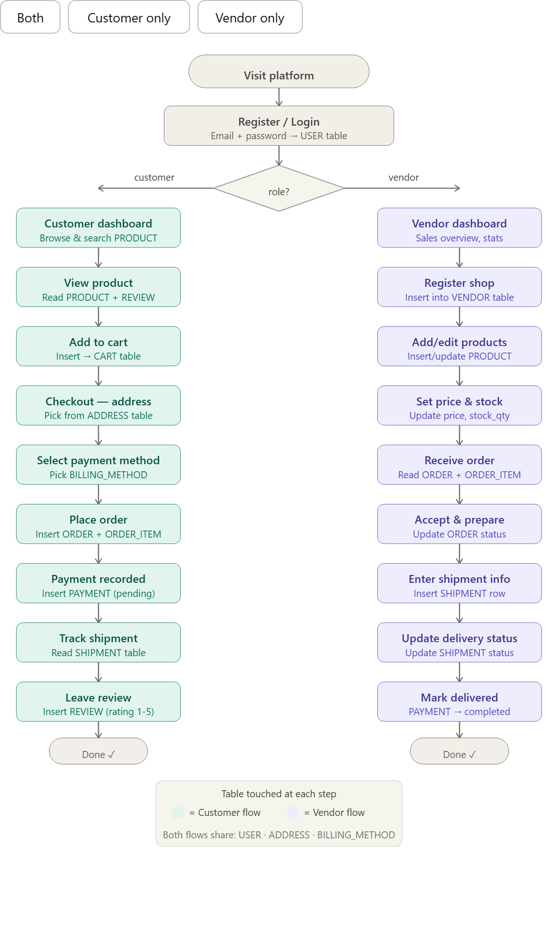

3. Dataflow Description
This section describes how data moves through the Multi-Vendor E-Commerce Marketplace System from the moment a user interacts with the platform to the moment a result is stored or returned.
3.1 Customer purchase flow
Data entry begins when a customer registers an account. Their name, email, hashed password, phone number, and role (customer) are inserted into the USER table. When they save a delivery address, it is written to ADDRESS with a reference to their user_id.
When the customer browses products, the system performs SELECT queries on PRODUCT joined with VENDOR and CATEGORY to return filtered listings. When they click Add to Cart, a row is inserted into CART linking their user_id and the product_id with a quantity.
At checkout, the system reads all CART rows for that user, calculates a total, then creates one row in ORDER (with billing and shipping address references) and one row in ORDER_ITEM for each product in the cart. The CART rows for that user are then deleted. A PAYMENT row is simultaneously inserted with status set to pending. Once payment is confirmed (via the selected BILLING_METHOD), the PAYMENT record is updated to completed and paid_at is stamped.
3.2 Vendor product and shipment flow
Data enters the vendor side when a vendor registers. Their user account is created in USER with role set to vendor, and a corresponding row is inserted in VENDOR with their shop name and details. When they list a product, a row is inserted in PRODUCT referencing their vendor_id and the appropriate category_id.
When a customer places an order containing their product, the vendor receives a notification. They view the ORDER and its ORDER_ITEM rows, prepare the parcel, and insert a row into SHIPMENT with the courier name, tracking number, and estimated delivery date. The ORDER status is updated to shipped and the SHIPMENT.shipment_status progresses from dispatched to in_transit to delivered as events occur.
3.3 Review flow
After an order reaches delivered status, the customer can submit a review. A row is inserted into REVIEW linking their user_id and the product_id with a rating (1–5) and optional comment. The system can then compute aggregate ratings per product by averaging REVIEW.rating for each product_id.

3.4 Data outputs
The system produces several types of output queries: product listings filtered by category or keyword, order status pages for customers, vendor dashboards showing revenue and pending orders, admin reports showing total transactions and registered users, and shipment tracking pages showing courier and delivery details.

Dataset summary — actual files generated
All CSV files have been generated with realistic Pakistani names, cities, phone numbers, product titles, and prices. The files are included in this submission and in the GitHub repository under the dataset/ folder.
CSV File | Row Count
users.csv | 80
vendors.csv | 20
categories.csv | 10
products.csv | 50
addresses.csv | 80
billing_methods.csv | 55
orders.csv | 81
order_items.csv | 101
payments.csv | 81
shipments.csv | 54
reviews.csv | 60
cart.csv | 60

